LAB – 3
PYTHON BASIC PRACTICE – III
210905407

import numpy as np
A = np.array ([2,5,10])
print(A.dtype)

O/P:

$ python3 ex1.py
int64

import numpy as np
S=np.arange(10,30,5)
print(S)

$ python3 ex1.py
[10 15 20 25]

import numpy as np
a = np.arange(15).reshape(3, 5)

$ python3 ex1.py
[[ 0 1 2 3 4]
[ 5 6 7 8 9]
[10 11 12 13 14]]

import random
print(random.choice([1,2,3,4,5])) #this will pick one number from
print(random.choice('python')) #will pick one character from the

print(random.randrange(25,50)) #will pick one integer between 25 to

print(random.randrange(25,50,2)) #will pick one integer between 25

print(random.random()) #will pick a random number between 0 to 1

print(random.uniform(5,10)) #will pick a floating point number

print(random.shuffle([1,2,3,4,5])) #will shuffle the list elements

print(random.seed(10)) #to get same random value during every

$ python3 ex1.py
1
p
36
47
0.2712630276183554
7.402502531872158
None
None

#2- Dimensional array (Matrix)

a = np.arange(15).reshape(3, 5)
#array([[ 0, 1, 2, 3, 4],[ 5, 6, 7, 8, 9],[10, 11, 12, 13, 14]])

#to check the dimension
print(a.shape)
#(3,5)

print(a.size) # will return total elements in matrix (here 15)

# to transpose a matrix
print(a.T) # transposed to 5x3 matrix

#3- Dimensional array
c = np.arange(24).reshape(2,3,4)

# 1st value indicates (no of planes) (3,4) is the dimension
print(c)

c.shape #will return (2,3,4)

np.array_equal(c[1,...], c[1,:,:]) # will fetch all elements of 2nd plane

np.array_equal(c[...,2], c[:,:,2])

$ python3 ex1.py
[[[ 0 1 2 3]
[ 4 5 6 7]
[ 8 9 10 11]]

[[12 13 14 15]
[16 17 18 19]
[20 21 22 23]]]

import numpy as np

#Array operations
a = np.array( [20,30,40,50] )
b = np.arange( 4 )
print(b)
#array([0, 1, 2, 3])

c = a-b
print(c)
#array([20, 29, 38, 47])

print(b**2)
#array([0, 1, 4, 9])

print(10*np.sin(a))
#array([ 9.12945251, -9.88031624, 7.4511316 , -2.62374854])

print(a<35)
#array([ True, True, False, False], dtype=bool)

$ python3 ex1.py
[0 1 2 3]
[20 29 38 47]
[0 1 4 9]
[ 9.12945251 -9.88031624 7.4511316 -2.62374854]
[ True True False False]

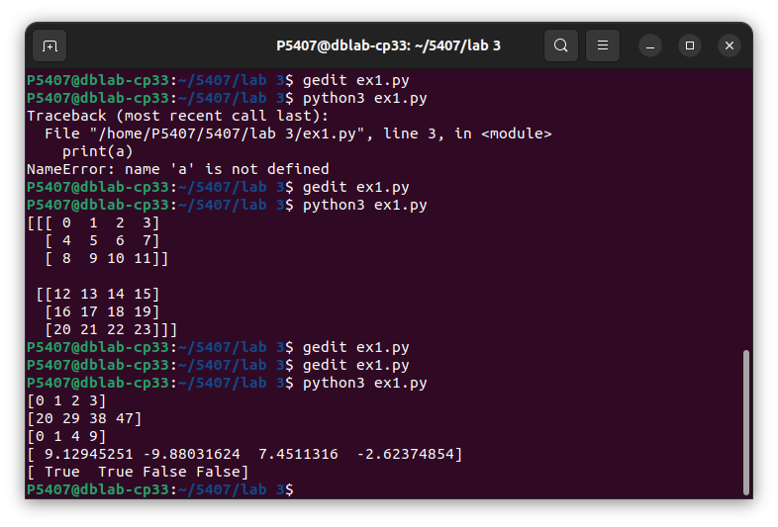

import numpy as np
#Matrix operations
A = np.array( [[1,1],[0,1]] )
B = np.array( [[2,0],[3,4]] )
print(A*B)

# elementwise product
#array([[2, 0],[0, 4]])
print(A.dot(B))

# matrix product
#array([[5, 4],[3, 4]])
#(OR)
print(np.dot(A, B))

#array([[5, 4],[3, 4]])
# another matrix productb = np.arange(12).reshape(3,4)
print(b)

#array([[ 0, 1, 2, 3],[ 4, 5, 6, 7],[ 8, 9, 10, 11]])
print(b.sum(axis=0))
#array([12, 15, 18, 21])# sum of each column

b.sum(axis=0)
#array([6, 22, 38])

P5407@dblab-cp33:~/5407/lab 3$ python3 ex1.py
[[2 0]
[0 4]]
[[5 4]
[3 4]]
[[5 4]
[3 4]]

import numpy as np
#Indexing, Slicing & Iterating Array
a = np.arange(10)**3
print(a)
#array([ 0, 1, 8, 27, 64, 125, 216, 343, 512, 729])

print(a[2:5])
#array([ 8, 27, 64])

print(a[0:6:2])
#array([0,8,64,216])

#Let ‘b’, is an input matrix of size 5x4
b=np.array([[ 0, 1, 2, 3],
[10, 11, 12, 13],
[20, 21, 22, 23],
[30, 31, 32, 33],
[40, 41, 42, 43]])
print(b[2,3]) #will fetch 23

print(b[:, 1]) # This will fetch the second column

print(b[-1,:]) # will fetch last row

print(b[:,-1]) # will fetch last col
for row in b:
print (row, end= ' ') # will print every row

for element in b.flat:
print (element,end =' ') # will show all elements of b in 1−D array
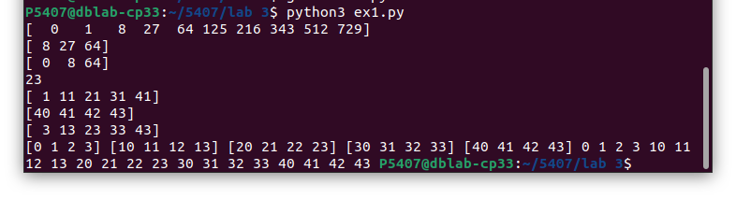

import numpy as np
b=np.array([[ 0, 1, 2, 3],
[10, 11, 12, 13],
[20, 21, 22, 23],
[30, 31, 32, 33],
[40, 41, 42, 43]])
#Changing the shape of a matrix
print(b.ravel()) # returns the array flattened to (1x 20)

#Later, we can convert 5x4 matrix into 4x 5 matrix using
B1=b.reshape(4,5)

#Stacking together different arrays
A1=np.array([(3,4,5),(12,6,1)])

A2=np.array([(1,2,6),(-4,3,8)])

D1=np.vstack((A1,A2))
print(D1)

D2=np.hstack((A1,A2))
print(D2)

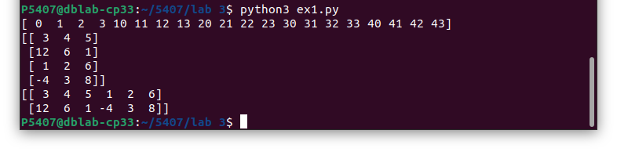
import numpy as np
#Stacking 1-D array into 2-D array (column wise)
a = np.array([4.,2.])
b = np.array([3.,8.])

print(np.column_stack((a,b))) # returns a 2D array
#array([[ 4., 3.],[ 2., 8.]])

np.hstack((a,b))
# the result is different
#array([ 4., 2., 3., 8.])

np.hstack((a[:,np.newaxis],b[:,np.newaxis])) # the result is the same
#array([[ 4., 3.],[ 2., 8.]])

#Indexing with array of indices
a = np.arange(12)**2
i = np.array( [ 1,1,3,8,5 ] )
print(a[i])

#array([ 1, 1, 9, 64, 25])
# the first 12 square numbers
# an array of indices
# the elements of a at the positions i
j = np.array( [ [ 3, 4], [ 9, 7 ] ] ) # a bidimensional array of indices
print(a[j])

# the same shape as j
#array([[ 9, 16],[81, 49]])

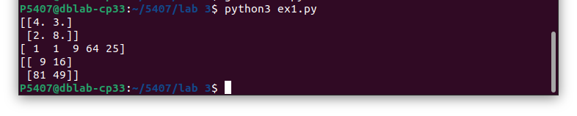

import numpy as np
#Usage of for-loop (Mapping by Value)
#Calculate sum of all the elements in a 2D Numpy Array (iterate over elements)

a=np.array([(3,2,9),(1,6,7)])
s1=0
for row in a:
for col in row:
s1+=col
print(s1)

#Usage of for-loop (Mapping by Index)
#Calculate sum of all the elements in a 2D Numpy Array (iterate over range)

a=np.array([(3,2,9),(1,6,7)])
s=0
for i in range(a.shape[0]):
for j in range(a.shape[1]):
s+=a[i,j]
print(s)

P5407@dblab-cp33:~/5407/lab 3$ python3 ex1.py
28
28
